Exercises on the PROMETHEE and GAIA methods

Exercise 1
A qualitative criterion is expressed on the following 9-point scale:

9 – Very Good
8 – between Very Good and Good
7 – Good
6 – between Good and Average
5 – Average
4 – between Average and Bad
3 – Bad
2 – between Bad and Very Bad
1 – Very Bad

For the decision maker, a 2-points difference is considered as very important, while a 1-point difference is not negligible but is felt less important.
What would be a correct preference function choice in this case?

- Usual type (no thresholds)
- Level type with q = 0.5 and p = 1.5
- Linear type with q = 1 and p = 2
- Level type with q = 1.5 and p = 2.5
- V-shape type with p = 1

Exercise 2
A preference function of type Linear, with q = 5 and p = 10 is associated to a quantitative criterion f. The criterion is to minimise. Let us compare two actions a and b such that f(a) = 37 and f(b) = 44.
We have:

- π(a,b) = 0 and π(b,a) = 0.4
- π(a,b) = 0 and π(b,a) = 0.7
- π(a,b) = 0.4 and π(b,a) = 0
- π(a,b) = 0.7 and π(b,a) = 0
- π(a,b) = 0 and π(b,a) = 0

Exercise 3
A multicriteria decision problem including five actions (A, B, C, D and E) has been analysed using the PROMETHEE method. The following results have been obtained:

π (.,.) | A | B | C | D | E | φ⁺ | φ
A | 0.000 | 0.375 | 0.500 | 0.375 | 0.500 | 0.43750 | 0.06250
B | 0.250 | 0.000 | 0.125 | 0.375 | 0.375 | 0.28125 | -0.18750
C | 0.500 | 0.500 | 0.000 | 0.375 | 0.625 | 0.50000 | 0.21875
D | 0.250 | 0.500 | 0.250 | 0.000 | 0.375 | 0.34375 | -0.03125
E | 0.500 | 0.500 | 0.250 | 0.375 | 0.000 | 0,40625 | -0.06250
φ⁻ | 0.37500 | 0.46875 | 0.28125 | 0.37500 | 0.46875

Is it true that:

- Yes No – A is the best ranked action.
- Yes No – D and E are incomparable in PROMETHEE I.
- Yes No – C is preferred to E in both PROMETHEE rankings.
- Yes No – There are multiple incomparabilities in PROMETHEE I.
- Yes No – D is preferred to E in PROMETHEE II.
- Yes No – B is the worst ranked action.

Exercise 4
A multicriteria decision problem including seven actions (A1 to A7) and five criteria (C1 to C5) has been analysed using the GAIA method (Δ = 89%).

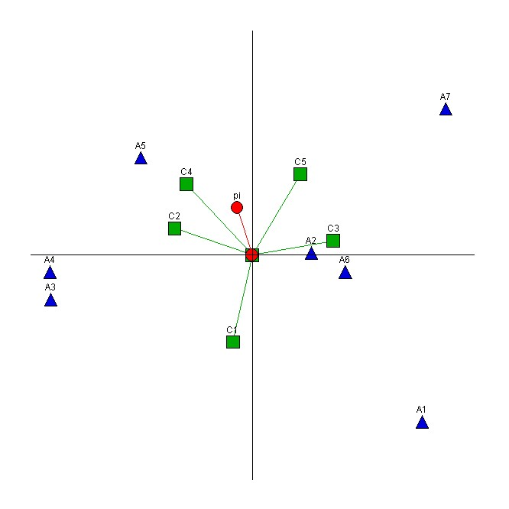

Is it true that:

- Yes No – The quality of the GAIA representation is good.
- Yes No – A7 seems to be very good on criterion C3.
- Yes No – A3 and A4 have similar profiles.
- Yes No – Much weight has been given to C3.
- Yes No – C2 and C3 are not conflicting.
- Yes No – Four clusters of actions can be identified.

